Option 1:

Step 1:

Complete “Programming Projects: Introduction to Linux Kernel Modules” at the end of Chapter 2 in the online (enhanced eText) version of the recommended book.
- Part 1 - “Kernel Modules Overview”
- Part 2 - “Loading and Removing Kernel Modules

The files simple.c and Makefile referenced in the OSC textbook may be found in the Ubuntu VM, in the folder ~/final-src-osc10e/ch2/ .

- Open a command line window, type the following
  - cd ~/
  - mkdir Project2
  - cd Project2
  - mkdir Option1Step1
  - cd Option1Step1

- Copy the files simple.c and Makefile
  - cp ~/final-src-osc10e/ch2/simple.c .
  - cp ~/final-src-osc10e/ch2/Makefile .

- While completing this step, in addition to creating your C program for Part 2, create screenshots of the dmesg output for both Parts 1 and 2 and include these screenshot files in your Step1 folder

Step 2:

Complete Part 1 of “Project 3 – Linux Kernel Module for Listing Tasks” in the Programming Projects section at the end of chapter 3

#Include line is truncated in OSC10e-Ch3-ProgProg.pdf

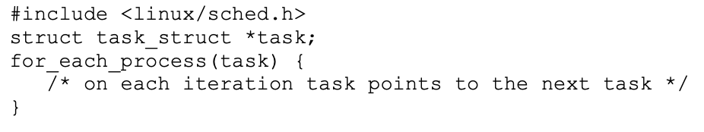

- Open a command line window, type the following
  - cd ~/Project2
  - mkdir Option1Step2
  - cd Option1Step2
- While completing this step, in addition to creating your C program for Part 2, create screenshots of the following:
  - The dmesg output when installing your kernel module
  - The output of running the command ps -el in the command line window
  - Include these screenshots in Option1Step2 file

